13-4-2019

**david gutierrez alvarez**



## EL ÁRBOL BINARIO DE BÚSQUEDA, IMPLEMENTACIÓN DINÁMICA

|  |
| --- |
| **RESUMEN PERSONAL Y FORMA DE ABORDAR EL PROBLEMA** |

A pesar de que este trabajo no fue algo muy fácil el echo de ya tener conocimientos y practica no se me dificulto a la hora de implementarlo, aun me falta mejorar en mi forma de codificar pero con todas las practicas que hemos tenido ya puedo hacer algo decente

|  |
| --- |
| **Main.cpp** |
| #include <iostream>  #include "menu.h"  *using* *namespace* std;  int **main**() {  Menu menu;  menu.selectOption();  *return* 0;  } |

|  |
| --- |
| **Menú.h** |
| #ifndef MENU_H  #define MENU_H  #include <iostream>  #include "BTree.h"  *class* **Menu** {  *private*:  BTree tree;  *enum* **option**{  *generate* = 1,  *preorder*,  *inorder*,  *postorder*,  *close*  };  *public*:  **Menu**();  long **random**();  void **generated**(size_t i4);  void **selectOption**();  };  #endif *//* *MENU_H* |

|  |
| --- |
| **Menú.cpp** |
| #include "menu.h"  #include <random>  #include <chrono>  *using* std::cout;  *using* std::cin;  *using* std::endl;  Menu::**Menu**() { }  void Menu::**generated**(size_t i) {  *for* (i; i > 0; i--) {  cout << random();  cout << tree.insert(random());  }  }  void Menu::**selectOption**() {  string option;  size_t rand;  *do* {  cout << "\t\t\t\t\t\t\t.:MENU:." << endl  << *generate* <<".- generar numeros aleatorios" << endl  << *preorder* << ".- mostrar en preorden" << endl  << *inorder* << ".- mostrar en inorden" << endl  << *postorder*<< ".- mostrar en postorden" << endl  << "escoje una opcion";  getline(*cin*, *option*);  *switch* (option[0]) {  *case* '1':  tree.clear();  cout << "cuantos numeros quieres generar: ";  cin >> rand;  cin.ignore();  generated(rand);  *break*;  *case* '2':  tree.prePrint();  *break*;  *case* '3':  tree.inPrint();  *break*;  *case* '4':  tree.postPrint();  *break*;  *case* '5':  cout << "adios" << endl;  *break*;  *default*:  cout << "valor incorrecto" << endl;  }  } *while* (option != to_string(*close*));  }  long Menu::**random**() {  std::default_random_engine engine{std::chrono::steady_clock::now().time_since_epoch().count()};  std::uniform_int_distribution<int> range{0, 1000000};  long random_generated = range(engine);  *return* random_generated;  } |

|  |
| --- |
| **BTree.h** |
| #ifndef BTREE_H  #define BTREE_H  #include <iostream>  *using* *namespace* std;  *class* **BTree** {  *private*:  *struct* **Node** {  int i;  Node *left;  Node *right;  };  Node *root;  void **clear** (Node *&n) {  *if*(n != *nullptr*) {  clear(*n->left*);  clear(*n->right*);  *delete* n;  }  }  int **insert**(Node *&r,Node *&n) {  *if*(r == *nullptr*) {  r = n;  *return* 0;  }  *if*(r->i > n->i) {  *if*(!r->left) {  r->left = n;  *return* 0;  }  *if*(r->left) {  *return* insert(*r->left*, *n*);  }  }  *if*(r->i <= n->i) {  *if*(!r->right) {  r->right = n;  *return* 0;  }  *if*(r->right) {  *return* insert(*r->right*,*n*);  }  }  *return* -1;  }  void **inPrint**(Node *n) *const* {  *if*(n != *nullptr*) {  inPrint(n->left);  cout << n->i << endl;  inPrint(n->right);  }  }  void **prePrint**(Node *n) *const* {  *if*(n != *nullptr*) {  cout << n->i << endl;  prePrint(n->left);  prePrint(n->right);  }  }  void **postPrint**(Node *n) *const* {  *if*(n != *nullptr*) {  postPrint(n->right);  cout << n->i << endl;  postPrint(n->left);  }  }  bool **find** (Node *n, int i) *const* {  *if*(n->i == i) {  *return* 1;  }  *if*(n->i <= i) {  *if*(n->right) {  *return* find(n->right,i);  }  *if*(!n->right) {  *return* 0;  }  }  *if*(n->i > i) {  *if*(n->left) {  *return* find(n->left,i);  }  *if*(!n->right) {  *return* 0;  }  }  }  int **count**(Node *n) *const* {  *if*(n) {  *return* 1+ (count(n->left))+(count(n->right));  }  *if*(!n) {  *return* 0;  }  }  int **seek**(Node *&n , int i) {  *if*(n->i == i) {  destroy(*n*);*//* *call* *destroy*  *return* 0;  }  *if*(n->i <= i) {  *if*(n->right) {  *return* seek(*n->right*, i);  }  *if*(!n->left) {  *return* -1;  }  }  *if*(n->i > i) {  *if*(n->left) {  *return* seek(*n->left*, i);  }  *if*(!n->left) {  *return* -1;  }  }  *return* -1;  }  void **destroy**(Node *&n) {  *if*(!n->left && !n->right) {  *delete* n;  n = NULL;  } *else* {  Node *l;  Node *r;  l = n->left;  r = n->right;  *delete* n;  n = NULL;  copy(l);  copy(r);  }  }  void **copy**(Node *n) {  *if*(n != *nullptr*) {  insert(*root*,*n*);  }  }  *public*:  **BTree**() : root(*nullptr*){ }  **BTree**(*const* BTree &rhs) {  root = *nullptr*;  *operator*=(rhs);  }  ~**BTree**() {  *if*(root) {  clear();  *delete* root;  }  }  BTree& *operator* = (*const* BTree &rhs) {  *if*(root) {  clear(*root*);  root = NULL;  }  Node *temp;  Node *nerd;  temp = rhs.root;  *if*(!temp) {  *return* \**this*;  }  *while*(temp) {  *if*(!temp->left) {  insert(temp->i);  temp = temp->right;  } *else* {  nerd = temp->left;  *while*(nerd->right && nerd->right != temp) {  nerd = nerd->right;  }  *if*(!nerd->right) {  nerd->right = temp;  temp = temp->left;  } *else* {  nerd->right = NULL;  insert(temp->i);  temp = temp->right;  }  }  }  *return* \**this*;  }  bool *operator* == (*const* BTree &rhs) {  int red[2];  red[0] = count(root);  red[1] = count(rhs.root);  *if*(red[0] == red[1]) {  *return* 1;  }  *return* 0;  }  bool *operator* < (*const* BTree &rhs) {  int red[2];  red[0] = count(root);  red[1] = count(rhs.root);  *if*(red[0] < red[1]) {  *return* 1;  }  *return* 0;  }  bool **isFull**() {  *if*(root != *nullptr*) {  *return* 1;  }  *if*(!root)  {  *return* 0;  }  }  bool **isEmpty**() {  *if*(root != *nullptr*) {  *return* *false*;  }  *return* *false*;  }  void **clear**() {  *if*(root != *nullptr*) {  clear(*root*);  root = NULL;  }  }  int **insert**(int i) {  Node *temp;  temp = *new* Node;  temp->i = i;  temp->left = *nullptr*;  temp->right = *nullptr*;  *return* insert(*root*,*temp*);  }  bool **find**(int i) *const* {  *if*(root) {  *return* find(root, i);  }  *if*(!root) {  *return* 0;  }  }  int **remove** (int i) {  *if*(root != *nullptr*) {  *return* seek(*root*,i);  }  *return* -1;  }  void **inPrint**() *const* {  *if*(root != *nullptr*) {  inPrint(root);  cout << endl;  }  }  void **prePrint**() *const* {  *if*(root != *nullptr*) {  prePrint(root);  cout << endl;  }  }  void **postPrint**() *const* {  *if*(root != *nullptr*) {  postPrint(root);  cout << endl;  }  }  };  #endif *//* *BTREE_H* |

|  |
| --- |
| **CAPTURAS DE PANTALLA** |

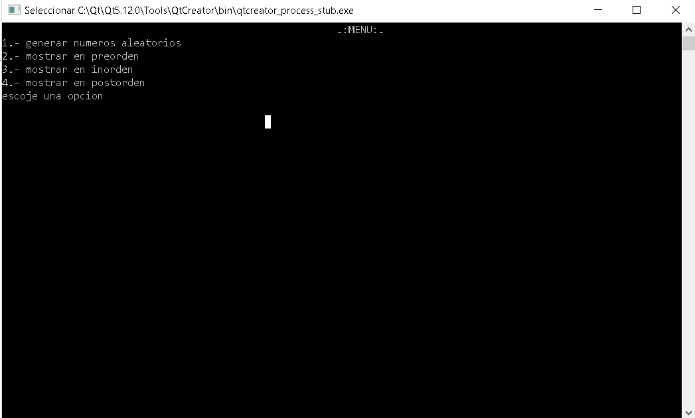

Menú

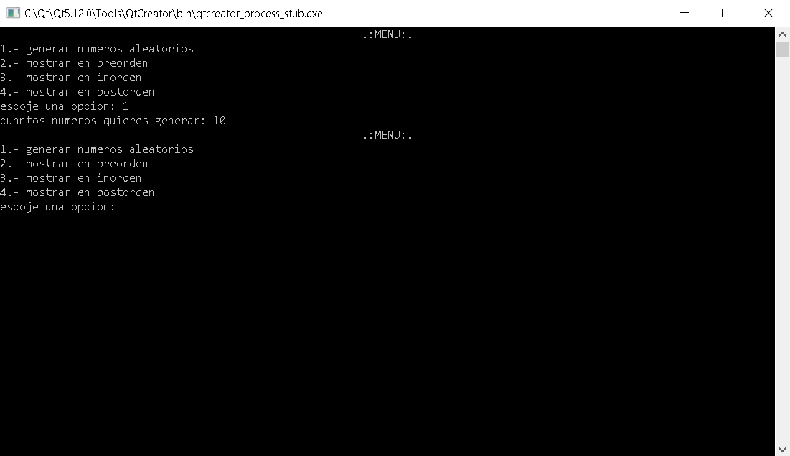

Aquí se generaron 10 numeros random

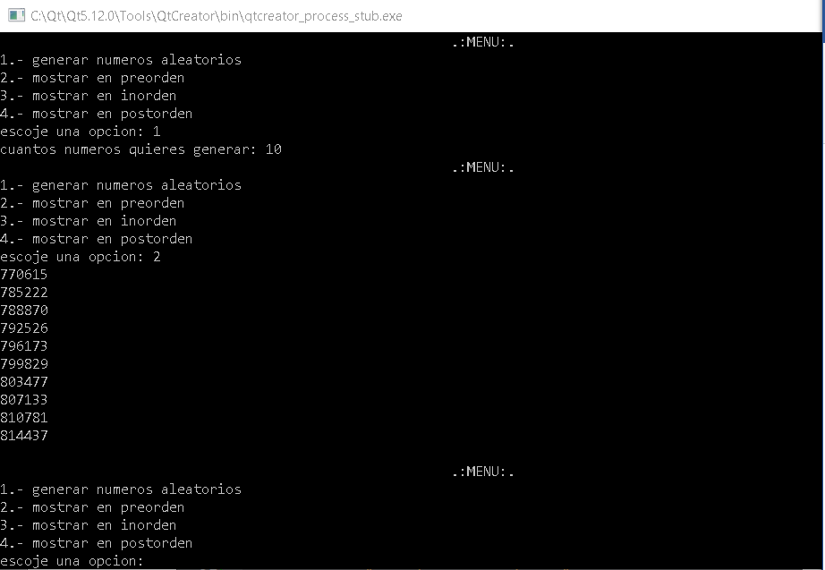

Vista en preorden

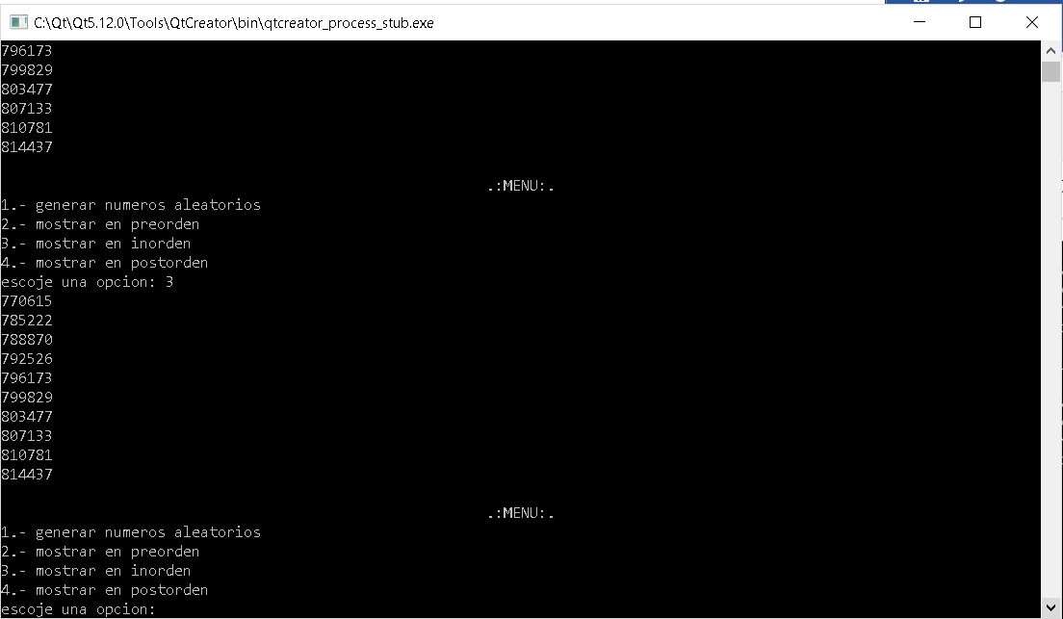

Vista en inorden

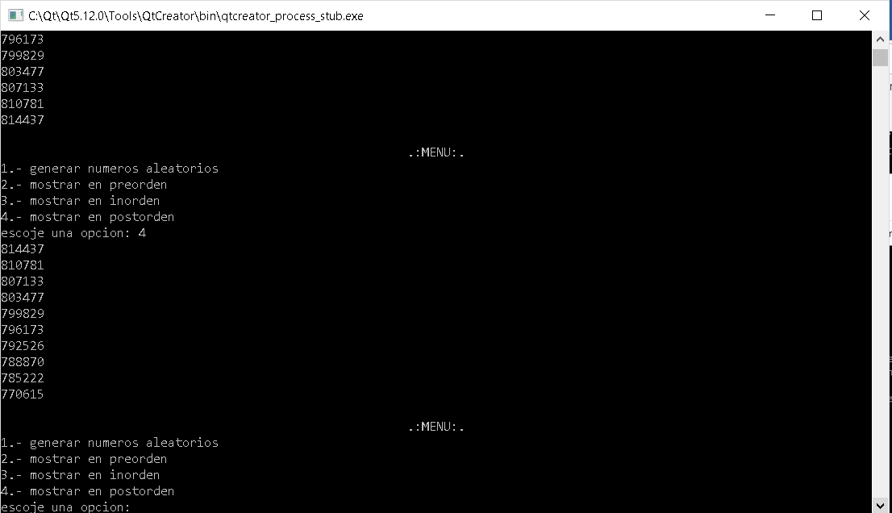

Vista en postorden